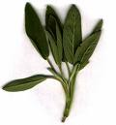
menu
Rolls
Fresh sage and onion bread rolls.
Sushi
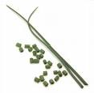
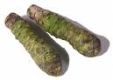
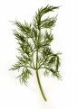
Courgette sheets wrapped around smoked salmon slivers, avocado slices, asparagus tips, dill, exotic mushrooms and mascarpone, spiced with wasabe and tied with chives lying on a passion fruit bed.
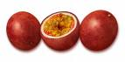
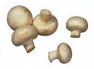

Main
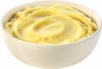
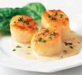
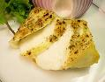
Plump pan-fried Scallops topped with nests of spiralized crispy beetroot swimming in glossy pools of raisin-caper sauce in a white wine reduction. They wink across the plate at seared lozenges of Sea Bass dressed in emerald spinach jewels on fluffy pillows of vanilla celery puree. Vegetarian jellies wait in attendance - celery and Ricard partnered by beetroot and balsamic.

Dessert
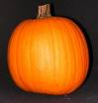
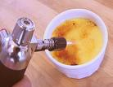
Creamy crème brulees drunk on Grand Marnier with nutmeg, slivers of crystallized ginger and pureed roast pumpkin. Their cinnamon sugar topping will be caramelised for your pleasure.

Chocolate
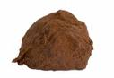
White chocolate and chilli chocolate truffles will be served with coffee.
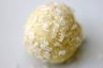

Digestif
A homemade chilli vodka cocktail will finish you off altogether.



